Position Title: Home Program Intern
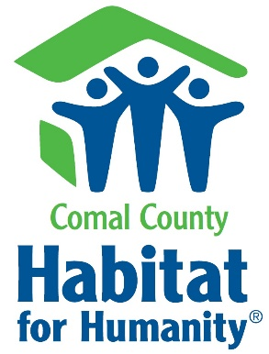
This location is not MSW certified.

Comal County Habitat for Humanity is a nonprofit organization that works together with the surrounding community to provide homeownership for families in need. Qualified families are given the ability to plant solid roots and grow, both through volunteering and affordable housing. As a Home Program Intern, you will work alongside the Home Program Coordinator and Home Director of Operations to aid in community outreach, plan and assist in homeowner financial classes, and help with the application process.

Duties and tasks the intern will be responsible for:

- Work with a supervisor to aid in identifying people qualified for partnership with Comal County Habitat for Humanity
- Gain real-life case-management experience
- Participate in Community Outreach; which includes networking with other area organizations, assisting in marketing efforts, and more
- Maintain and update homebuyer records and homebuyer binders with Home Program Coordinator/supervisor.
- Completion of homeowner OFAC checks as requested
- Aid with coordination of potential homeowner and homeownership classes
- Assist in numerous office tasks such as scheduling, filing records, and arranging meetings, answering phone calls, and assisting client walk-ins
- Assist in communication efforts with homebuyers in the queue, homeowners, and potential family applicants
- Other tasks as needed and assigned

What we are looking for:

- Must express a passion for nonprofit organizations
- Detail-orientated and highly organized
- Ability to work independently, as well with others in a team environment
- Able to prioritize necessary tasks on a daily basis
- Must be able to develop an objective review of candidates
- MS Office skills, especially Word, Excel, Publisher, and PowerPoint
- Will be required to pass a background check due to highly sensitive information and family interaction
- Must dedicate at least eight (8) hours of your time in the office per week
- Must site host one Thursday or Saturday a month

This position is not paid, but the experience you will gain is priceless.

